名字:_________ 日期 _______________

- Match the pictures with the correct words.

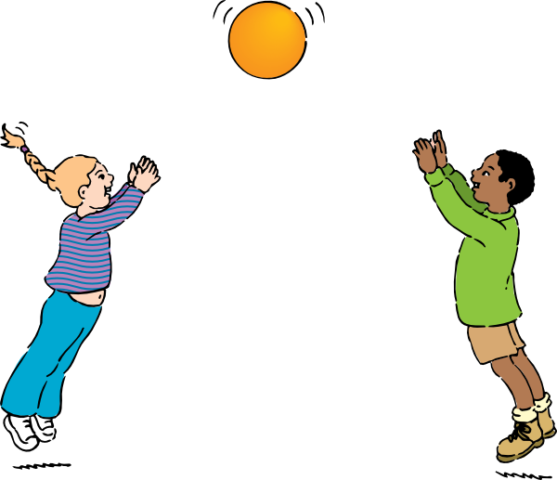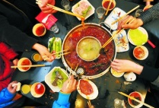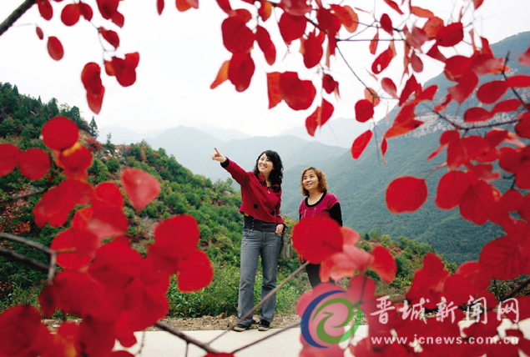

吃 火 锅 看 红 叶 划 船 放 风 筝 打球

Pictures:
- http://www.jinggangboat.com/p1/4人手划船.JPG
- http://www.clker.com/cliparts/c/6/b/d/1195445636200577762johnny_automatic_playing_ball.svg.hi.png
- http://pic1a.nipic.com/2008-10-31/200810317040126_2.jpghttp://pic1a.nipic.com/2008-10-31/200810317040126_2.jpg
- http://www.cq.xinhuanet.com/2012-04/17/111788849_11n.jpg
- http://www.cq.xinhuanet.com/2012-04/17/111788849_11n.jpg

